1. Coders here is a simple task for you, Given string str. Your task is to check whether it is a binary string or not by using python set.

Examples:

Input: str = "01010101010"

Output: Yes

Input: str = "REC101"

Output: No

**For example:**

|  |  |
| --- | --- |
| **Input** | **Result** |
| 01010101010 | Yes |
| 010101 10101 | No |

s=input()

if (set(s)=={'0','1'}):

print("Yes")

else:

print("No")

2. Given an array of integers nums containing n + 1 integers where each integer is in the range [1, n] inclusive.There is only **one repeated number** in nums, return *this repeated number*. Solve the problem using set.

**Example 1:**

**Input:** nums = [1,3,4,2,2]**Output:** 2

**Example 2:**

**Input:** nums = [3,1,3,4,2]**Output:** 3

**For example:**

|  |  |
| --- | --- |
| **Input** | **Result** |
| 1 3 4 4 2 | 4 |

l=[int(n) for n in input().split()]

a=set()

for i in l:

if i in a:

print(i)

a.add(i)

3. The **DNA sequence** is composed of a series of nucleotides abbreviated as 'A', 'C', 'G', and 'T'.

* For example, "ACGAATTCCG" is a **DNA sequence**.

When studying **DNA**, it is useful to identify repeated sequences within the DNA.

Given a string s that represents a **DNA sequence**, return all the **10-letter-long** sequences (substrings) that occur more than once in a DNA molecule. You may return the answer in **any order**.

**Example 1:**

**Input:** s = "AAAAACCCCCAAAAACCCCCCAAAAAGGGTTT"  
**Output:** ["AAAAACCCCC","CCCCCAAAAA"]

**Example 2:**

**Input:** s = "AAAAAAAAAAAAA"  
**Output:** ["AAAAAAAAAA"]

**For example:**

|  |  |
| --- | --- |
| **Input** | **Result** |
| AAAAACCCCCAAAAACCCCCCAAAAAGGGTTT | AAAAACCCCC CCCCCAAAAA |

x=input()

s=set()

r=set()

for i in range(len(x)-9):

ss=x[i:i+10]

if ss in s:

r.add(ss)

else:

s.add(ss)

r=list(r)

for j in r:

print(j)

4. Write a program to eliminate the common elements in the given 2 arrays and print only the non-repeating

elements and the total number of such non-repeating elements.

Input Format:

The first line contains space-separated values, denoting the size of the two arrays in integer format respectively.

The next two lines contain the space-separated integer arrays to be compared.

[Sample](https://www.rajalakshmicolleges.net/moodle/mod/quiz/view.php?id=5127) Input:

5 4

1 2 8 6 5

2 6 8 10

[Sample](https://www.rajalakshmicolleges.net/moodle/mod/quiz/view.php?id=5127) Output:

1 5 10

3

[Sample](https://www.rajalakshmicolleges.net/moodle/mod/quiz/view.php?id=5127) Input:

5 5

1 2 3 4 5

1 2 3 4 5

[Sample](https://www.rajalakshmicolleges.net/moodle/mod/quiz/view.php?id=5127) Output:

NO SUCH ELEMENTS

**For example:**

|  |  |
| --- | --- |
| **Input** | **Result** |
| 5 4 1 2 8 6 5 2 6 8 10 | 1 5 10 3 |

l=input()

l1=set(input().split(' '))

l2=set(input().split(' '))

l=list(l1^l2)

r=[]

for i in l:

r.append(int(i))

for i in sorted(r):

print(i,end=" ")

print()

print(len(l))

5. Given an array of strings words, return *the words that can be typed using letters of the alphabet on only one row of American keyboard like the image below*.

In the **American keyboard**:

* the first row consists of the characters "qwertyuiop",
* the second row consists of the characters "asdfghjkl", and
* the third row consists of the characters "zxcvbnm".

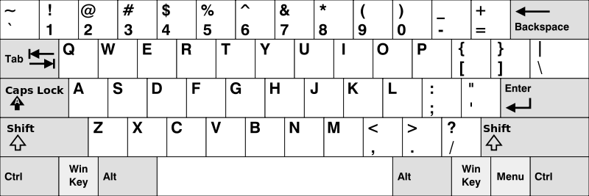

**Example 1:**

**Input:** words = ["Hello","Alaska","Dad","Peace"]  
**Output:** ["Alaska","Dad"]

**Example 2:**

**Input:** words = ["omk"]  
**Output:** []

**Example 3:**

**Input:** words = ["adsdf","sfd"]  
**Output:** ["adsdf","sfd"]

**For example:**

|  |  |
| --- | --- |
| **Input** | **Result** |
| 4 Hello Alaska Dad Peace | Alaska Dad |
| 2 adsfd afd | adsfd afd |

l=[]

t=[]

n=int(input())

for i in range(n):

l.append(input())

for i in l:

f=1

if i[0] in "qwertyuiopQWERTYUIOP":

for j in i:

if j not in "qwertyuiopQWERTYUIOP":

f=0

break

if f==1:

t.append(i)

elif i[0] in "asdfghjklASDFGHJKL" :

for j in i:

if j not in "asdfghjklASDFGHJKL":

f=0

break

if f==1:

t.append(i)

elif i[0] in"zxcvbnmZXCVBNM":

for j in i:

if j not in "zxcvbnmZXCVBNM":

f=0

break

if f==1:

t.append(i)

if len(t)==0:

print("No words")

else:

for i in t:

print(i)